

**Semester Two**

**Examination 2017**

**Question/Answer booklet**

**MATHEMATICS**

**SPECIALIST UNITS 3 & 4**

**Section Two:**

**Calculator-assumed**

|  |
| --- |
| Student Name: _____________________________________ |
| Teacher’s Name: _____________________________________ |

**Time allowed for this section**

Reading time before commencing work: ten minutes

Working time for paper: one hundred minutes

**Material required/recommended for this section**

**To be provided by the supervisor**

This Question/Answer booklet

Formula Sheet (retained from Section One)

**To be provided by the candidate**

Standard items: pens (blue/black preferred), pencils (including coloured), sharpener, correction tape/fluid, erasers, ruler, highlighters

Special Items: drawing instruments, templates, notes on two unfolded sheets of A4 paper, and up to three calculators approved for use in the WACE examinations.

**Important note to candidates**

No other items may be taken into the examination room. It is **your** responsibility to ensure that you do not have any unauthorised notes or other items of a non-personal nature in the examination room. If you have any unauthorised material with you, hand it to the supervisor **before** reading any further.

**Structure of this paper**

|  |  |  |  |  |  |
| --- | --- | --- | --- | --- | --- |
|  | Number of questions available | Number of questions to be attempted | Working time (minutes) | Marks available | Percentage of exam |
| **Section One**  **Calculator—free** | **8** | **8** | **50** | **50** | **35** |
| Section Two  Calculator—assumed | 14 | 14 | 100 | 100 | 65 |
|  | | | |  | 100 |

**Instructions to candidates**

1. The rules for the conduct of Western Australian external examinations are detailed in the

*Year 12 Information Handbook 2017.* Sitting this examination implies that you agree to abide by these rules.

1. Answer the questions according to the following instructions.

**Show all your working clearly.** Your working should be in sufficient detail to allow your

answers to be checked readily and for marks to be awarded for reasoning. Incorrect answers given without supporting reasoning cannot be allocated any marks. For any question or part question worth more than two marks, valid working or justification is required to receive full marks. If you repeat an answer to any question, ensure that you cancel the answer you do not wish to have marked.

It is recommended that you **do not use pencil**, except in diagrams.

1. You must be careful to confine your responses to the specific questions asked and to follow any instructions that are specific to a particular question.
2. Spare pages are included at the end of this booklet. They can be used for planning your responses and/or as additional space if required to continue an answer.

* Planning: If you use the spare pages for planning, indicate this clearly at the top of the page.
* Continuing an answer: If you need to use the space to continue an answer, indicate in the original answer space where the answer is continued, i.e. give the page number. Fill in the number of the question that you are continuing to answer at the top of the page.

1. The Formula Sheet is **not** handed in with your Question/Answer Booklet.

# Section Two: Calculator–assumed 65% (100 marks)

This section has **fourteen (14)** questions. Attempt **all** questions. Write your answers in the spaces

provided.

Working time: 100 minutes

**Question 9 (6 marks)**

The functions f and g are defined as 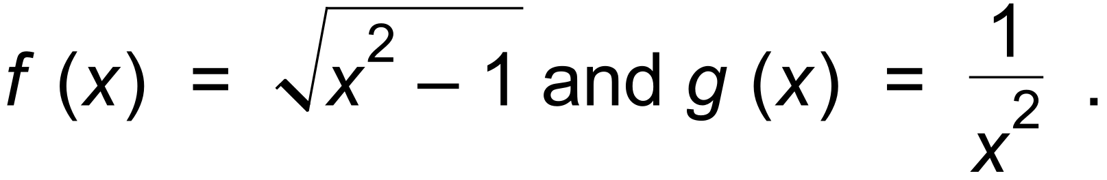

(a) Determine the expressions for:

(i) g o f (x). (1 mark)

(ii) g o g (x). (1 mark)

(b) For g o f (x) state:

(i) the domain. (2 marks)

(ii) the range. (1 mark)

(c) Given k (x) = x2 + 4 and h o k (x) = | x |, determine the function h (x). (1 mark)

**Question 10 (8 marks)**

On the axes below sketch the locus of the complex number z = x + yi, given by:

(a) | z + 1 − 2i | ≤ 1 and | z + i | ≥ | z − (2 + i) | . (4 marks)

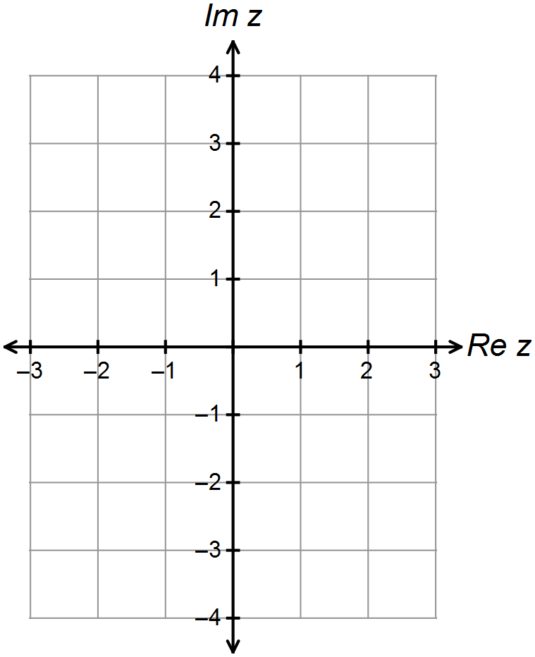



(b) 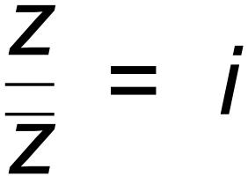 . (2 marks)

(c) Given that a = 1 + 2i and b = 3 + 4i, sketch on the complex plane below;

{ z : | z − a | + | z − b | = | a − b | }. (2 marks)

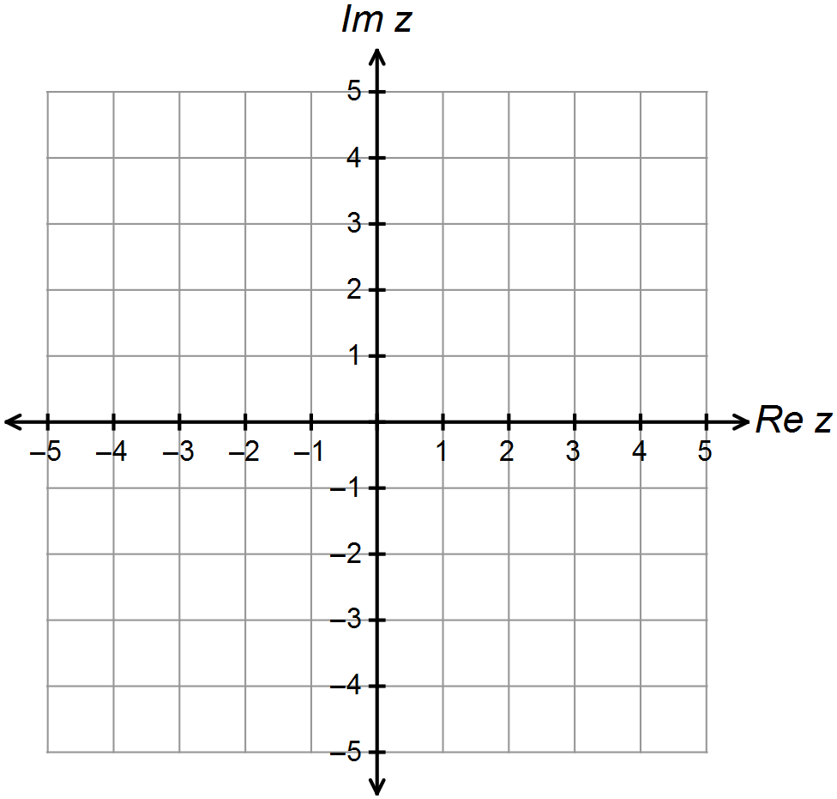

**Question 11 (5 marks)**

A section of the graph of the curve 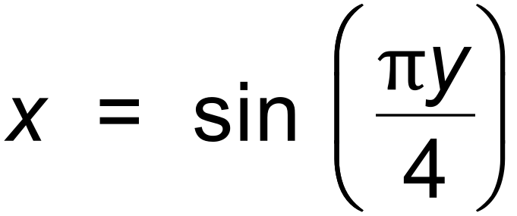 in the first quadrant is sketched below.

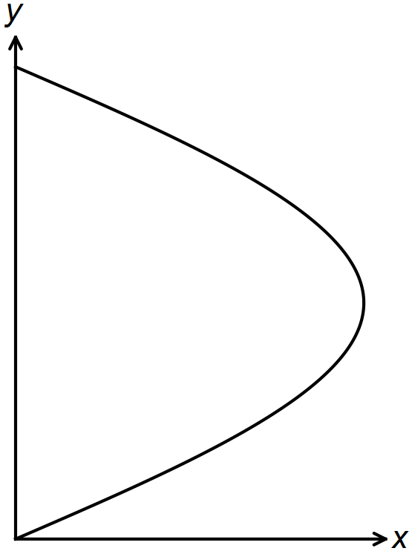

(a) Find an expression for  (2 marks)

(b) Determine the area of the region bounded by the curve 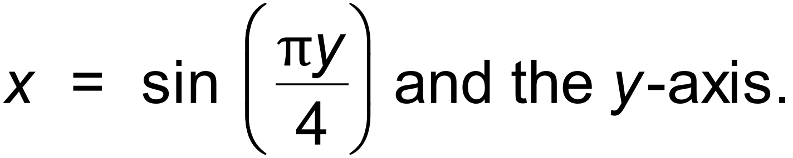

(ie. The loop above.) (3 marks)

**Question 12 (6 marks)**

A first order differential equation has a slope field as shown in the diagram below.

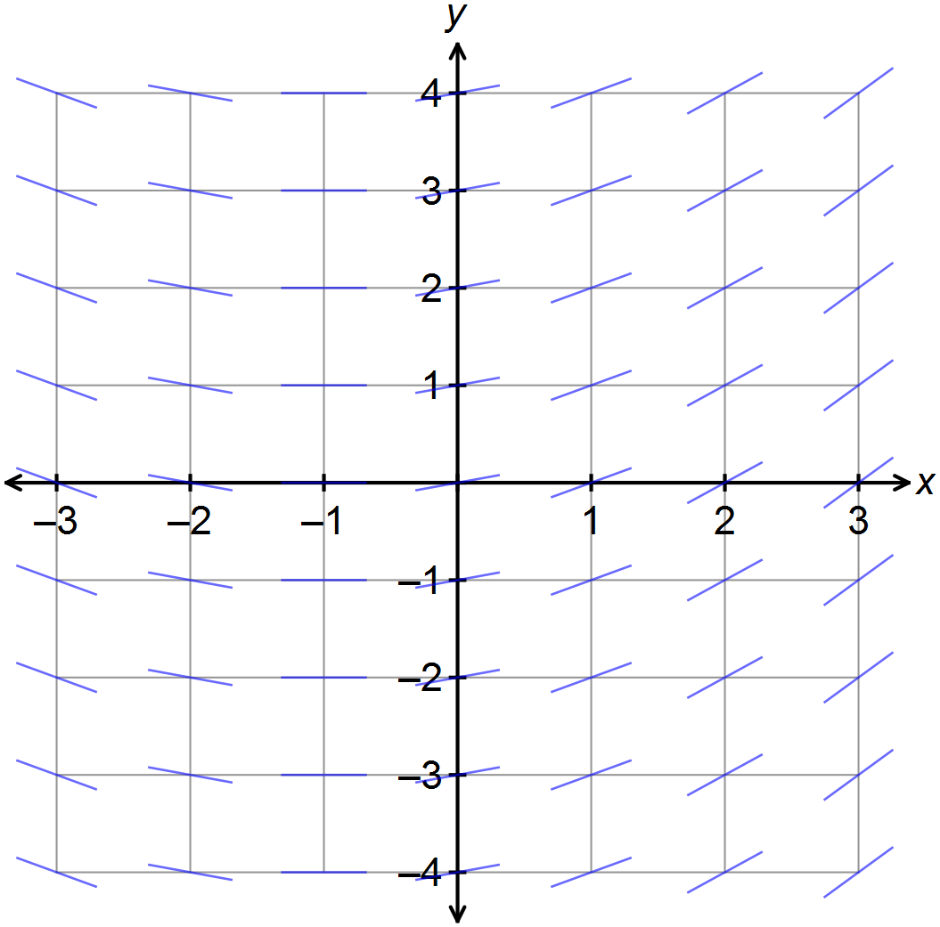

(a) Determine the general differential equation that would give this slope field. (3 marks)

(b) The slope field at point A (0, 1) has a value of 0.25.

Determine the equation for the curve *y* = *f* (*x*) containing A that is a solution to the differential

equation above. (3 marks)

**Question 13 (5 marks)**

The number of people, *P*, infected by a strain of influenza is modelled by

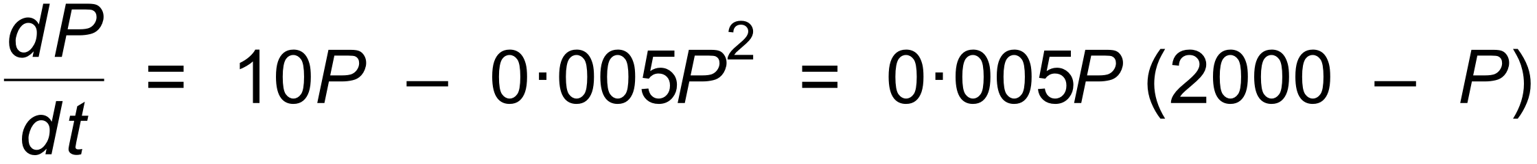 where *t* is the time in years after the outbreak.

There were 10 influenza cases initially observed.

The limiting size of the number of people infected is 2000.

The solution to the differential equation is given by the logistic curve:

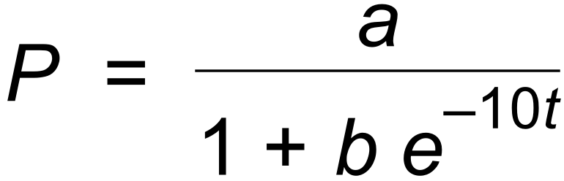 .

(a) State the values of *a* and *b* in the logistic equation. (2 marks)

(b) Find the time when the number of people infected is increasing at its greatest rate, and also

the population infected at this time. (3 marks)

**Question 14 (8 marks)**

The velocity *v* m/sec of a body moving in a straight line is given by 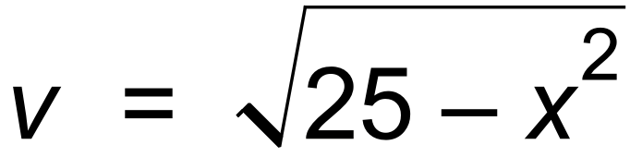 , where *x* cm is the displacement of the body from O, the origin.

(a) Show, using substitution and differentiation of the given curve, that:

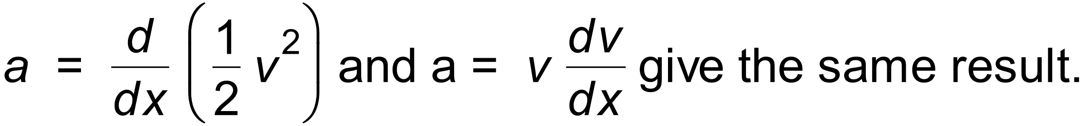 (2 marks)

(b) Find the velocity and acceleration of the body when it is 4 cm to the left of the origin O. (2 marks)

(c) Determine the exact value of *x* and *a* when *v* = 0. (2 marks)

(d) Calculate the exact velocity of the body when it has an acceleration of 2 cm/sec2. (2 marks)

**Question 15 (4 marks)**

Consider the three simultaneous equations with a, b and c as constants.

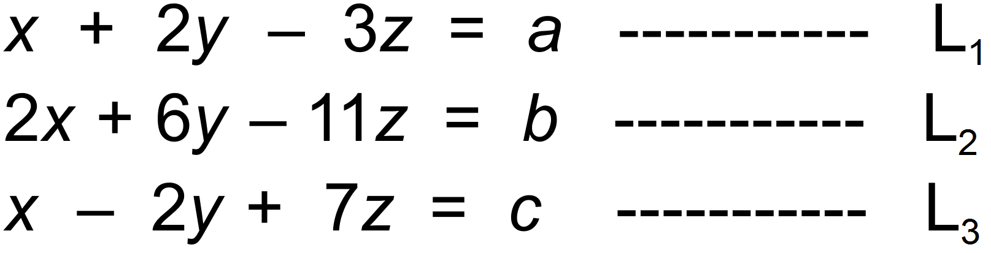

For what value(s) of a (if any) in terms of b and c does the above system have no solution?

(4 marks)

**Question 16 (5 marks)**

A particle in Simple Harmonic Motion travels from rest to rest, a distance of 30m in 5 seconds.

Find the particle’s:

(a) maximum speed. (3 marks)

(b) minimum acceleration and its displacement relative to the mean position at this instant. (2 marks)

**Question 17 (6 marks)**

(a) Sketch the graph of *f* (*x*) = | *x* + 1 | + | *x* − 1 | − 4. (1 mark)

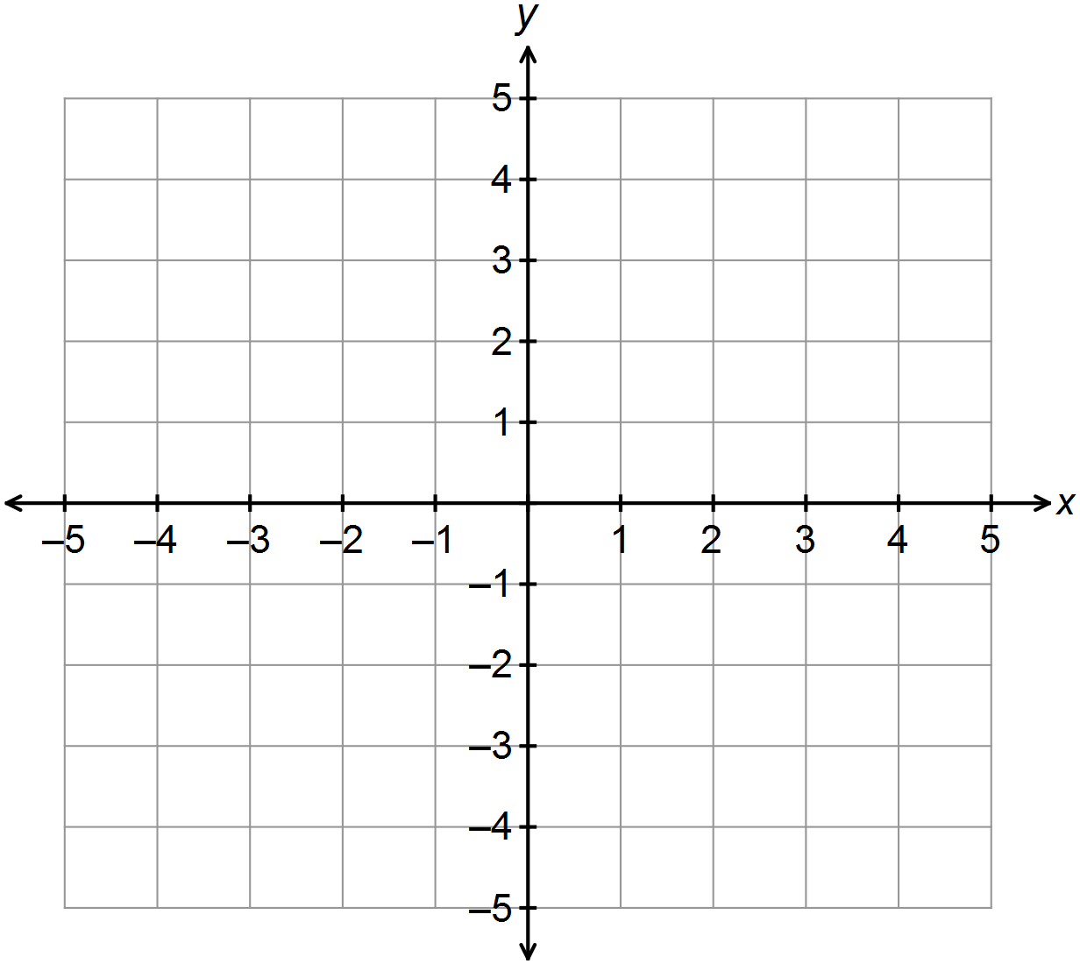

(b) The graph of *h* (*x*) = *a* | *x* + *b* | + *a* | *x* − *b* | − *c* is given below.

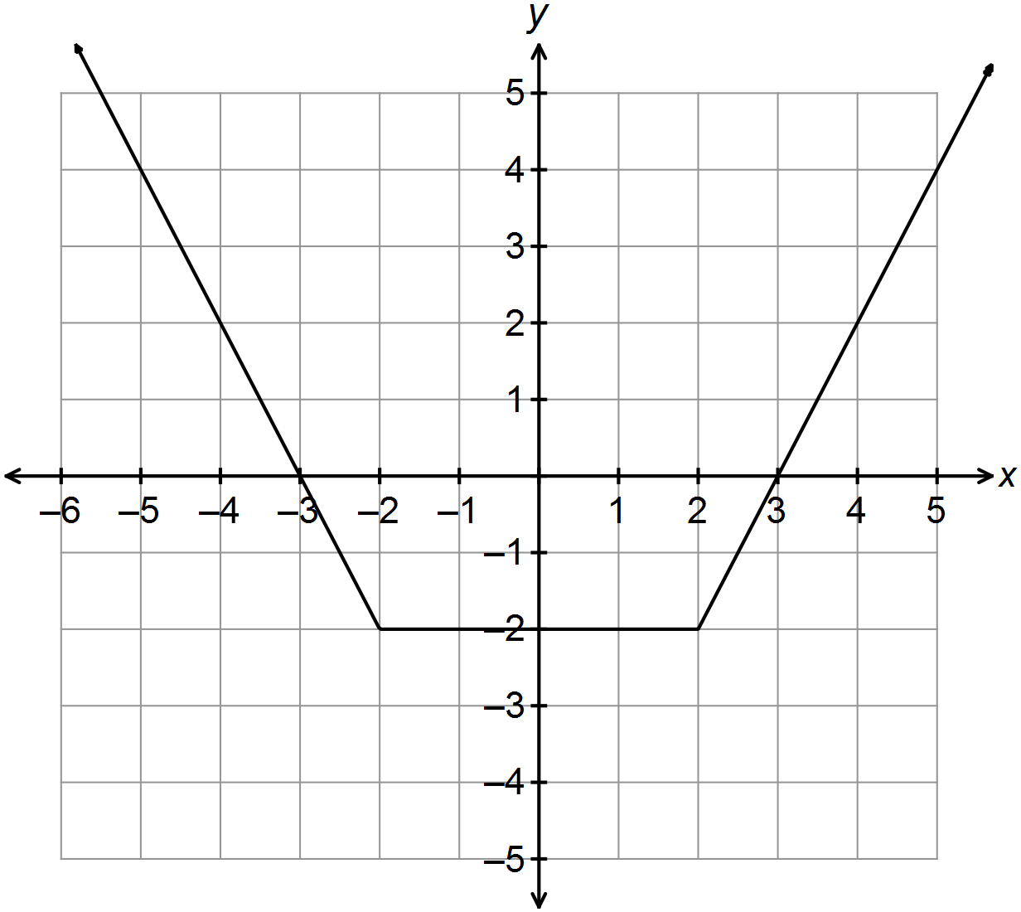 Determine the values of *a*, *b* and *c*. (3 marks)

(c) The graph of *g* (*x*) = 2*x* + *d* is such that *h* (*x*) = *g* (*x*) has only one solution.

Give the range of possible values for the constant *d*. (2 marks)

**Question 18 (11 marks)**

A 2 metre long watering trough for cattle is shown below. The trapezoidal face has height

1 metre and base width of 1 metre.

Initially the trough is full with water, but the cattle drink at a constant rate of 0.05 m3/hr.

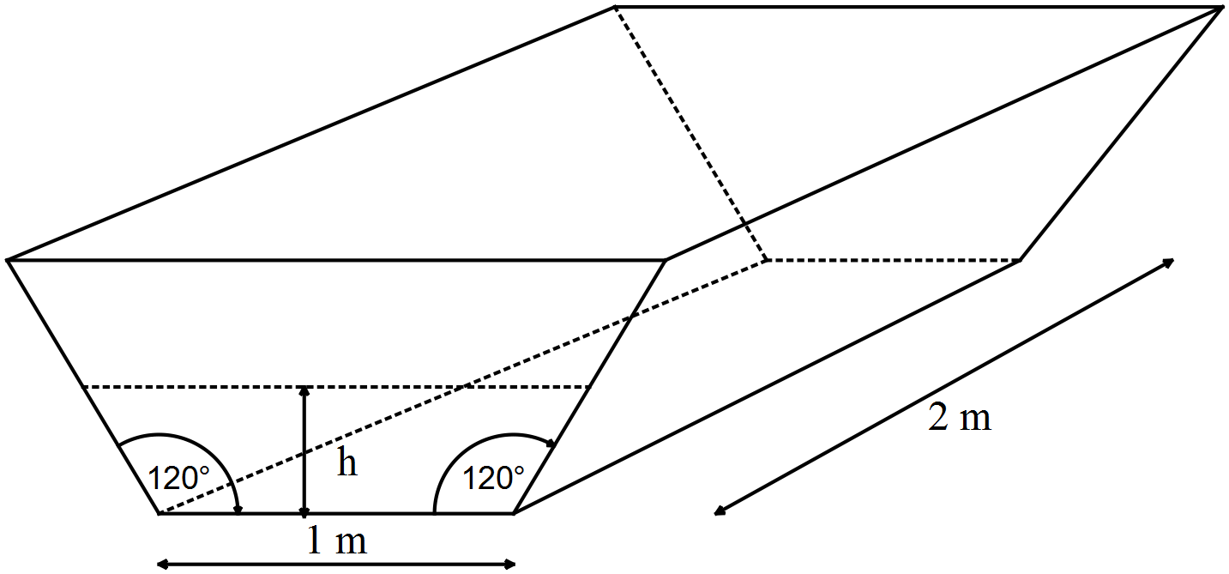

(a) Show that the volume of water in the trough, in m3, is given by:

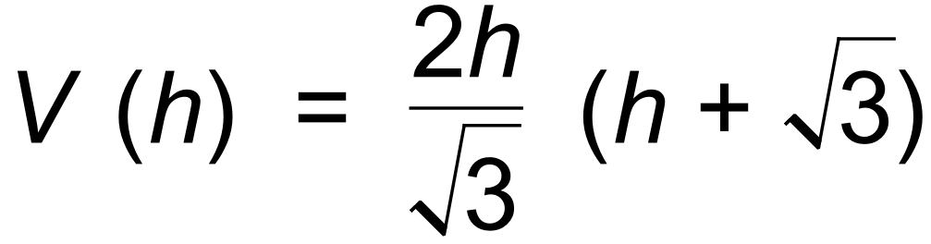 where *h* is the height of the water. (3 marks)

(b) Determine the rate of change of the depth correct to the nearest 0.001 m/hr when

the depth is 0.4 m. (3 marks)

(c) Show that the differential equation that relates 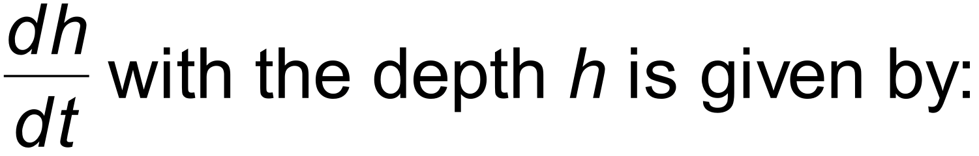 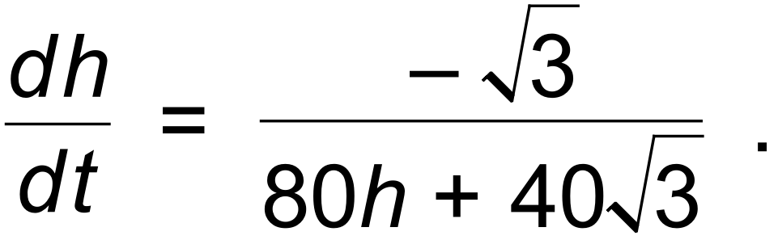 (2 marks)

(d) Hence, determine an expression for the time *t* in terms of *h*. (3 marks)

**Question 19(12 marks)**

The mass of crayfish caught near the Abrolhos Islands is observed to be normally distributed with a mean of .

Joe the fisherman catches 65 crayfish.

(a) Determine the probability that:

(i) the mean crayfish mass will be less than 1.15 kg. (3 marks)

(ii) the total mass will be between 75 kg and 80 kg. (3 marks)

On another fishing trip, we are required to be 98% confident that the mean crayfish mass differs from the population mean by less than 0.05 kg.

(b) Find the number of crayfish that need to be caught. (2 marks)

A rival crayfisherman, Jamie, has started catching crayfish further out to sea than Joe. Jamie states that the crayfish caught are significantly bigger than in the area that Joe fishes in.

Over a month Jamie catches 220 crayfish with total mass of 270 kg. Assume 

(c) Determine whether Jamie’s claim is supported at the 95% level of confidence. (4 marks)

**Question 20 (9 marks)**

A particle’s position vector, **r** (t) in metres, at any time t seconds is given by the equation:

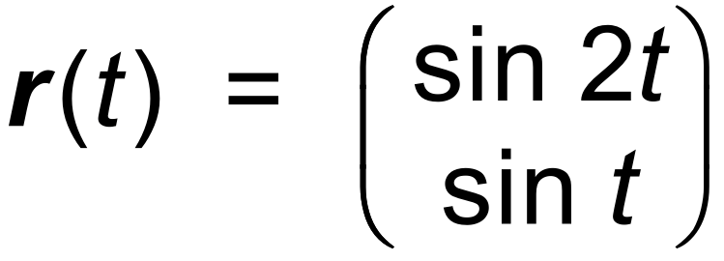

A plot of the path of the particle is shown below.

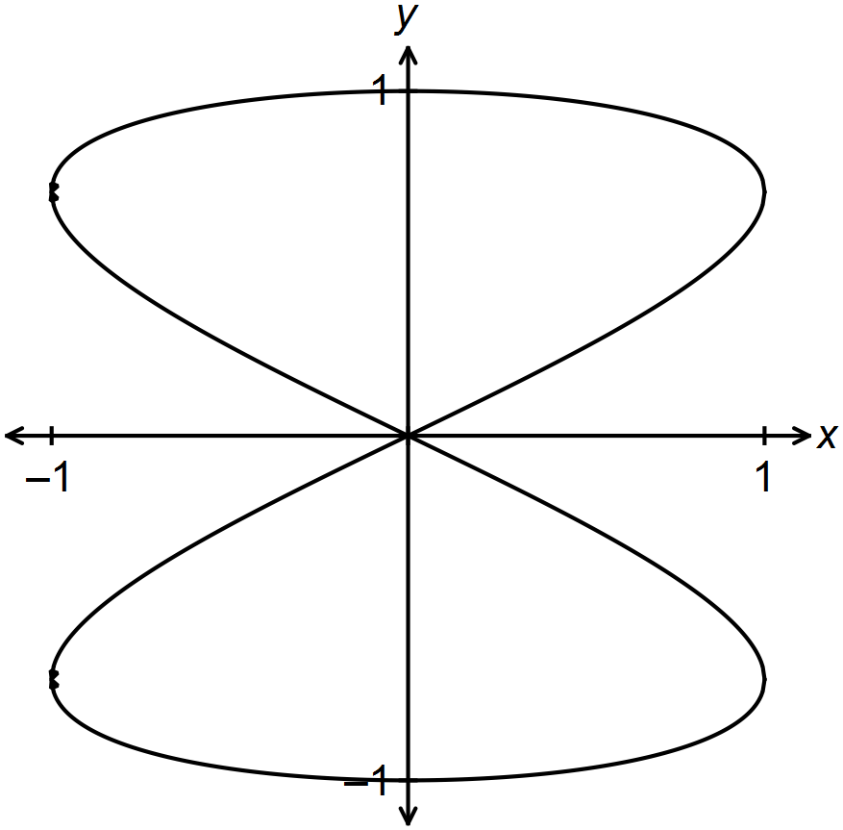

(a) Determine the Cartesian equation of the path in the form x2 = f (y). (2 marks)

(b) Determine the speed of the particle when it reaches the point where x = −0.5 for

the second time. (4 marks)

(c) Use the formula 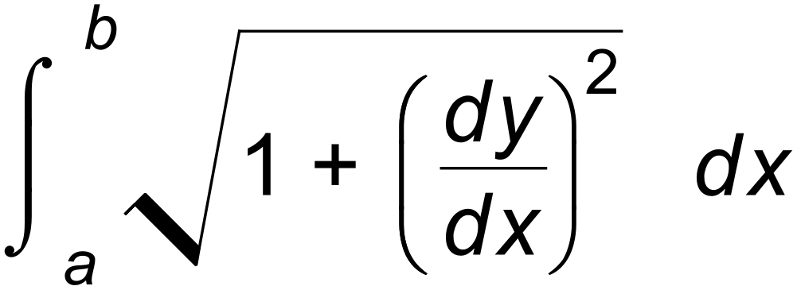 to find the distance travelled by the particle

in completing the whole course once. (3 marks)

**Question 21 (10 marks)**

Let A(1, 0, −3), B(3, −1, −1) and C(7, −3, 3) be three points.

Figure 1 shows the plane P1 through B, with  as its normal.

The points D(3, 5, 2) and E(1, −3, 0) are on this plane.

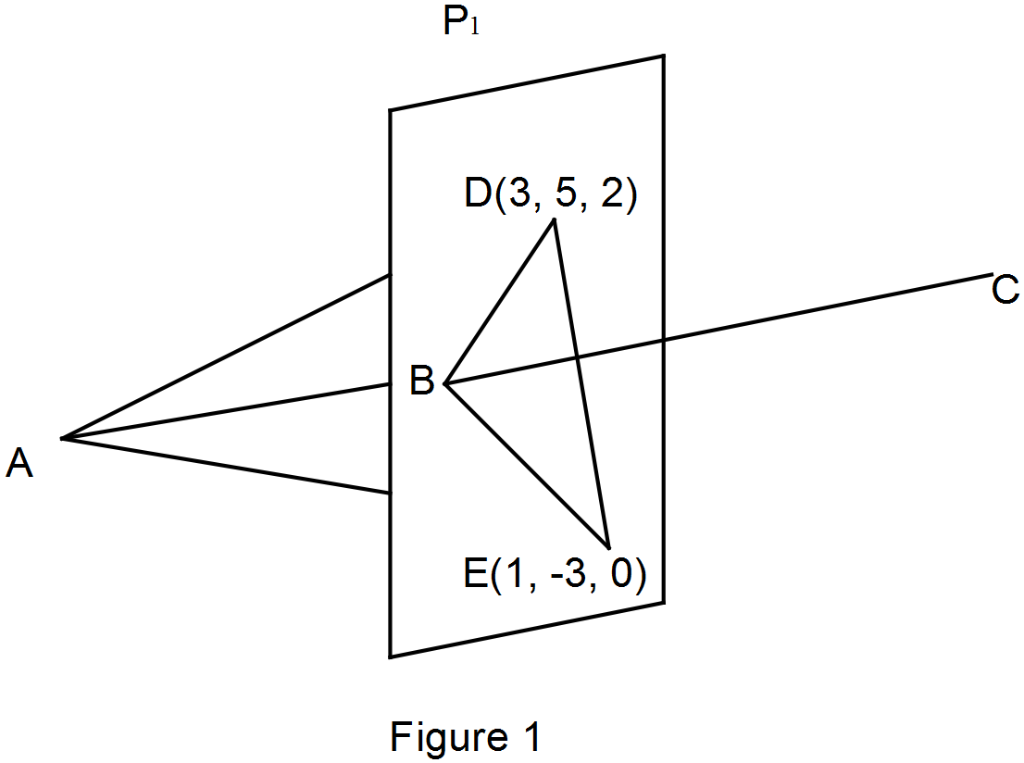

(a) If  (2 marks)

(b) Find the vector equation of the plane *P*1. (2 marks)

(c) Find the vector equation of the line through A and B. (1 mark)

Figure 2 shows that the lines AB, AD and AE continue on to meet the plane P3, which is

parallel to P1 and P2.

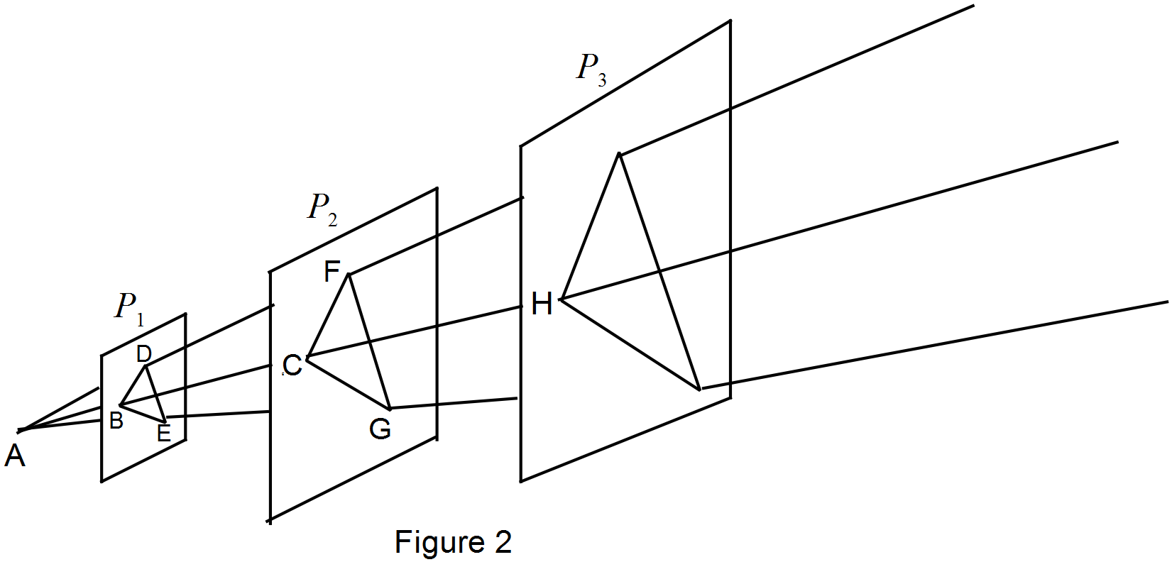

(d) Given that the area of ΔBDE = 9 units2, find the area of ΔCFG. (2 marks)

(e) Given that the area of the triangle that is projected onto *P*3 is 16 times the area of

ΔBDE, find the Cartesian equation of plane *P*3. (3 marks)

**Question 22 (5 marks)**

A sphere is obtained by rotating a semi−circle with equation 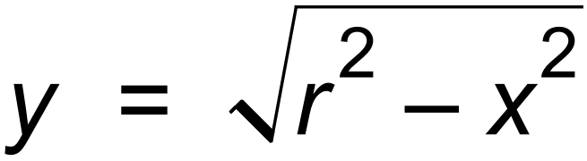 about the *x*−axis.

The sphere is sliced vertically at *x* = *a* and *x* = *b*, where −*r* ≤ *a* < *b* ≤ *r*.

(a) State the integral for the volume of the slice. (1 mark)

A spherical water melon has a diameter of 22 cm. A 2 cm slice is taken from the end of the melon.

(b) (i) Determine the volume of this slice. (2 marks)

(ii) Write the integral that would find the area, A, of the curved surface of this end slice, using the formula below. **Do not evaluate the integral**.

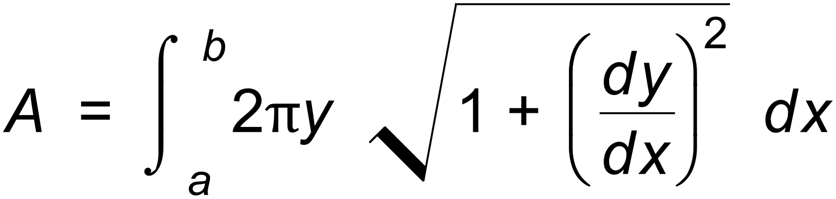 (2 marks)

**End of questions**

**Additional working space**

Question number(s): ……………………

**Additional working space**

Question number(s): ……………………